**Health & Safety Talk**

**Chemicals** 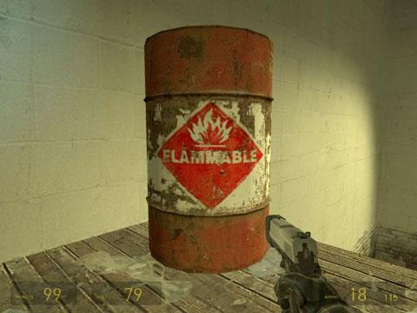

The variety of chemicals used in the automotive industry can pose a physical hazard, such as slipping on oil and also can pose a health hazard, such as two pack spray paints causing skin irritation or respiratory issues. Regardless if a chemical is hazardous or not, all chemicals need to stored, handled and used with caution, for the sake of a workers safety and the health of the environment.

**Some of the different types of chemicals found within an automotive workshop include:**

Acids Degreasers Oils

Paints Glues Petrol

**The risks associated with these chemicals can include:**

Human health hazards Environmental damage Explosion Fire

**Health Effects on exposure to these chemicals can include:**

Poisoning Irritation Burns Sensitisation

Cancer Birth defects Organ diseases Respiratory damage

**What should be done?**

* Only use chemicals for its intended use.
* Always refer to the Material Safety Data Sheet (MSDS) prior to use of an unfamiliar product.
* Ensure appropriate Personal Protective Equipment (PPE) is worn when using chemicals.
* Ensure chemicals that are decanted into bottles are adequately labelled and not decanted into drink bottles or food containers. Only use chemical containers to store chemicals for compatibility reasons.
* Always use personal hygiene practices (e.g. washing hands thoroughly) after working with chemicals.
* Clean up any spills immediately.
* Keep lids on containers if not in use to prevent any accidental spills.

**Who is responsible?**

Everyone is responsible for the safe and effective storage, handling and use of chemicals in the workplace.

|  |  |
| --- | --- |
| **Consultation** |  |

**Date of Meeting:**_____________________

**Attendees** (list attendees present)

|  |
| --- |
|  |

**Items Discussed**

|  |
| --- |
|  |

**Action Items**

|  |
| --- |
|  |

**Management Sign Off**

**Name:** _______________________________________

**Sign:** ___________________________________ **Date:** ______________________________